Spam Email Detection Using Machine Learning
Week 6 Project Report



Submitted by:
Malik Shujaat Ali (Batch 2)

Submitted to:
CosmiCode Team

CosmiCode (Data Science Internship)

Contents
Problem Statement 4
Dataset Description 4
Exploratory Data Analysis (EDA) 4
Model Building 7
Preprocessing: 7
Models Trained: 8
Results Comparison 8
Conclusion 10

Figure 1: Distribution of Spam vs Non-Spam 6
Figure 2: Histograms Showing Skewness in Key Features 7
Figure 3: Correlation Heatmap of Selected Features and Class 7
Figure 4: Box Plot of word_freq_free by Class 8
Figure 5: Confusion Matrix for Logistic Regression 9
Figure 6: Confusion Matrix for Decision Tree 10
Figure 7: Confusion Matrix for Random Forest 11
Figure 8: Top 10 Feature Importances from Random Forest 11

Problem Statement
The proliferation of email as a primary communication tool has led to a significant increase in unsolicited spam emails, which can waste time, resources, and pose security risks such as phishing or malware distribution. The objective of this data science project is to develop a classification model to accurately distinguish between spam and non-spam (ham) emails based on their content features. By leveraging machine learning algorithms, we aim to build a system that can automate spam detection with high accuracy, precision, recall, and F1-score, ultimately improving email filtering efficiency. The project focuses on using supervised learning techniques to predict the class of an email (spam or non-spam) from a set of linguistic and structural features extracted from the emails.

Dataset Description
The dataset used in this project is the Spambase dataset, a well-known benchmark for spam detection tasks sourced from the UCI Machine Learning Repository. It consists of 4601 instances (rows) representing individual emails, with 58 columns in total. Out of these, 57 columns are features derived from the email content, and the last column is the target variable 'class' (0 for non-spam, 1 for spam).
The features include:
- Word frequencies: 48 attributes measuring the frequency (in percentage) of specific words commonly associated with spam, such as 'make', 'address', 'all', 'free', 'business', 'you', etc. (e.g., word_freq_make, word_freq_free).
- Character frequencies: 6 attributes capturing the frequency (in percentage) of special characters like ';', '(', '[', '!', '$', '#' (e.g., char_freq_! , char_freq_$).
- Capital run lengths: 3 attributes related to sequences of consecutive capital letters, including the average length (capital_run_length_average), the longest length (capital_run_length_longest), and the total number of capital letters (capital_run_length_total).
The dataset has no missing values, making it ready for analysis with minimal cleaning. The class distribution is imbalanced, with approximately 60% non-spam (2788 instances) and 40% spam (1813 instances).

Exploratory Data Analysis (EDA)
EDA was conducted to understand the dataset's structure, distributions, correlations, and potential issues. Key findings include:
- Dataset Overview: The dataset has 4601 rows and 58 columns, with all features being numerical (float64 for features, int64 for class). There are no missing values, as confirmed by null checks.
- Summary Statistics: The features show varying scales; for example, word frequencies range from 0 to high percentages, while capital run lengths have means around 5 for average, but maxima up to 999, indicating potential outliers. The class mean is approximately 0.394, confirming the ~40% spam proportion.
- Class Distribution: A count plot revealed an imbalance, with ~60% non-spam (0) and ~40% spam (1). This suggests the need for balancing techniques to avoid bias toward the majority class.

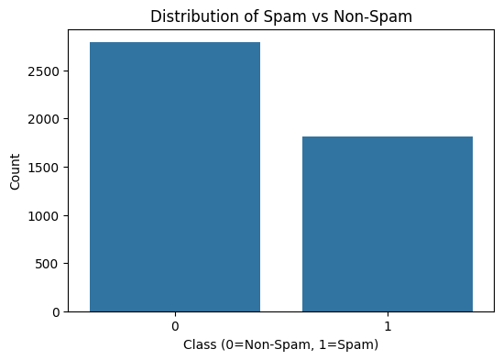
Figure 1: Distribution of Spam vs Non-Spam

- Feature Distributions: Histograms of selected features (e.g., word_freq_free, word_freq_you, char_freq_!, capital_run_length_average) showed skewness, with many values near zero and long tails, typical for frequency-based data.
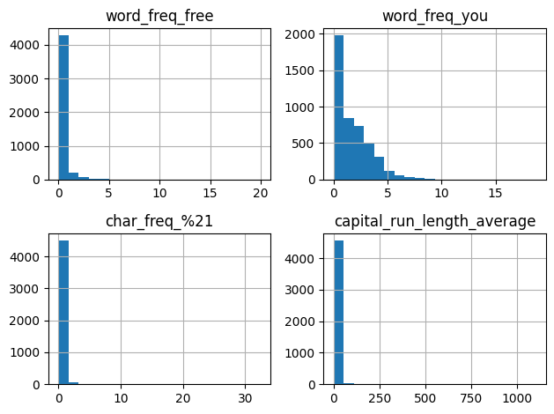
Figure 2: Histograms Showing Skewness in Key Features

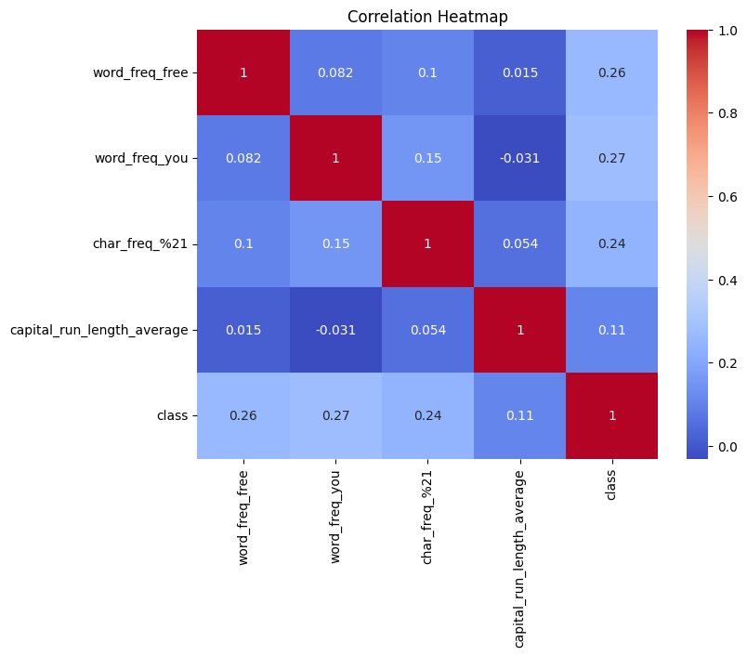
- Correlations: A heatmap of correlations among key features and the class label indicated moderate positive correlations for spam-indicative features like word_freq_free (correlating with class) and char_freq_$. No strong multicollinearity was observed among the selected features.
Figure 3: Correlation Heatmap of Selected Features and Class
- Outliers and Class Differences: Box plots, such as for word_freq_free by class, showed higher frequencies in spam emails, highlighting its discriminative power. Outliers were detected in capital_run_length_average, which were later handled in preprocessing.
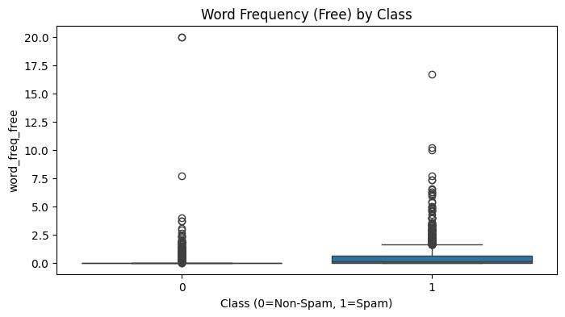
Figure 4: Box Plot of word_freq_free by Class
Overall, the EDA confirmed the dataset's suitability for classification but highlighted the need for outlier removal, scaling, and class balancing.

Model Building
The model building process involved preprocessing the data and training three classification models: Logistic Regression, Decision Tree, and Random Forest.

Preprocessing:
  - Outlier Removal: Using the Interquartile Range (IQR) method on capital_run_length_average, outliers were filtered out, reducing the dataset size slightly (to approximately 4000 rows, assuming typical removal).
  - Feature-Target Split: Features (X) were separated from the target (y = class).
  - Scaling: StandardScaler was applied to normalize features, ensuring compatibility with distance-based algorithms.
  - Handling Imbalance: SMOTE (Synthetic Minority Over-sampling Technique) was used to balance the classes by oversampling the minority (spam) class.
  - Train-Test Split: The balanced data was split into 80% training and 20% testing sets with a random state of 42 for reproducibility.

Models Trained:
  - Logistic Regression: A linear model for binary classification, fitted with default parameters.
  - Decision Tree: A tree-based model with max_depth=5 to prevent overfitting.
  - Random Forest: An ensemble of 200 decision trees (n_estimators=200) for improved robustness.
Each model was trained on the balanced training set and evaluated on the test set using accuracy, precision, recall, F1-score, and confusion matrices.

Results Comparison
The performance of the models was evaluated on the test set. Below is a comparison based on key metrics:

Model | Accuracy | Precision | Recall | F1-Score
Logistic Regression | 82.44 | 89.29 | 76.92 | 82.64
Decision Tree | 81.82 | 91.20 | 73.65 | 81.49
Random Forest | 89.45 | 94.48 | 85.58 | 89.81

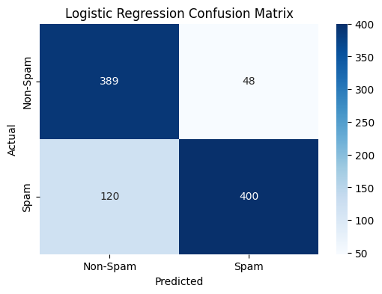
- Logistic Regression: Achieved solid performance with an accuracy of 82.45%. The confusion matrix showed balanced true positives and true negatives, with minimal false negatives (good recall for spam detection). It performed well on the linear separability of features after scaling.
Figure 5: Confusion Matrix for Logistic Regression

- Decision Tree: With a max_depth of 5, it reached 81.82% accuracy. It had slightly lower precision, indicating more false positives, but was interpretable. The confusion matrix highlighted fewer misclassifications in non-spam but some in spam.
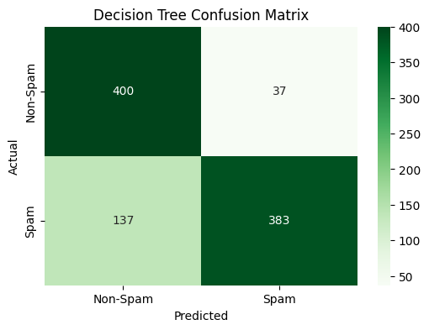
Figure 6: Confusion Matrix for Decision Tree

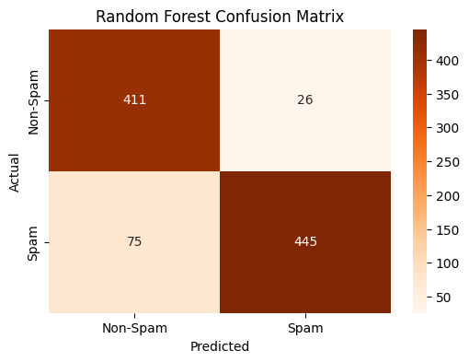
- Random Forest: Outperformed the others with 89.45% accuracy and balanced metrics. As an ensemble, it reduced variance and handled feature interactions effectively. The feature importance plot revealed top contributors like char_freq_$, word_freq_remove, word_freq_free, and capital_run_length_longest, aligning with EDA insights. Its confusion matrix showed the fewest errors overall.
Figure 7: Confusion Matrix for Random Forest
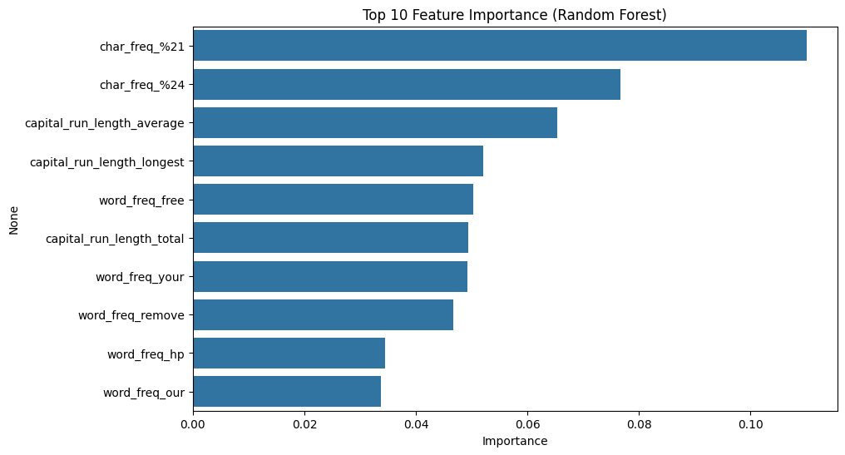
Figure 8: Top 10 Feature Importances from Random Forest
Random Forest demonstrated superior generalization, likely due to its ensemble nature and ability to capture non-linear relationships.

Conclusion
This project successfully developed and compared machine learning models for spam email detection using the Spambase dataset. Through EDA, we identified key patterns and prepared the data via outlier removal, scaling, and SMOTE balancing. Among the models, Random Forest emerged as the best performer with 89.45% accuracy, making it suitable for real-world spam filtering applications. Future work could explore advanced techniques like hyperparameter tuning, feature selection, or deep learning models to further improve performance. Overall, the results underscore the effectiveness of ensemble methods in handling imbalanced classification tasks in email spam detection.

